 | CHAROTAR UNIVERSITY OF SCIENCE & TECHNOLOGY  DEVANG PATEL INSTITUTE OF ADVANCE TECHNOLOGY AND RESEARCH | 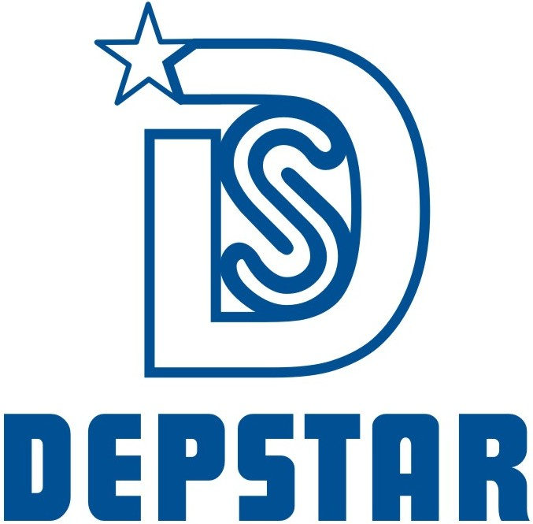

Weekly Report
In this report students require to mention the work has been done during the week and planning for the next week. (Please fill individual report for each week)

Student ID: 19DCS098 | Student Name: Parth Niteshkumar Patel
From Date: 28 June 2021 | To Date:10 July 2021
Semester: 5 | Internship ID: null

Work done in last week (Attach supporting Documents):

- Basics of Intermediate JavaScript

- Basics of Advanced JavaScript

- Completed Section-9, Section-10, Section-11,Section-12 and Section-13 of The Complete Web Development Bootcamp.

Projects Undertaken During Internship:

Total Projects Completed: 7

Projects given during current week: 2

Projects Completed during the current week: 2

Project Title:

- Make a Calculator

- Make a Instrumental App

Plans for next week:

NOTE: My internship tenure, domain as well as terms and conditions are changed.

So, internship will resume from July 27 2021

References:

- The Complete Web Development Bootcamp
URL: https://www.udemy.com/course/the-complete-web-development-bootcamp/

- Instructor’s Session

Project Screenshots:

Project: Calculator

Technologies Used: HTML, CSS and JavaScript

Description: It is a simple website which do basic calculations.

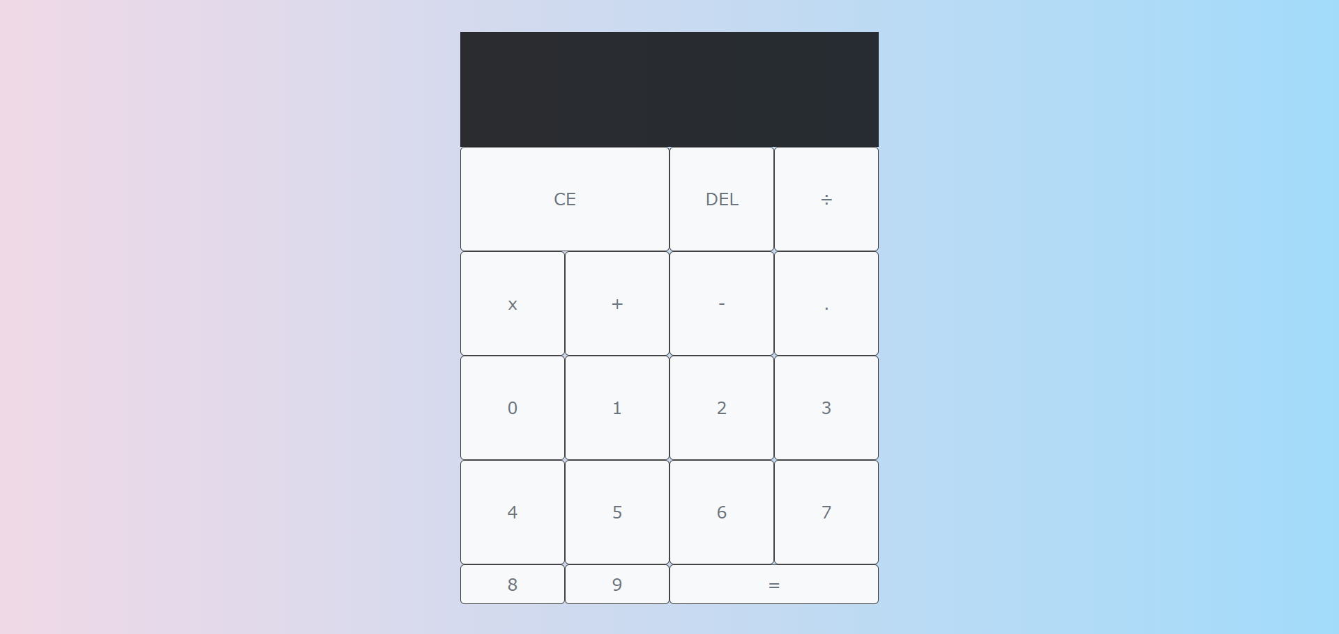

BASIC INTERFACE

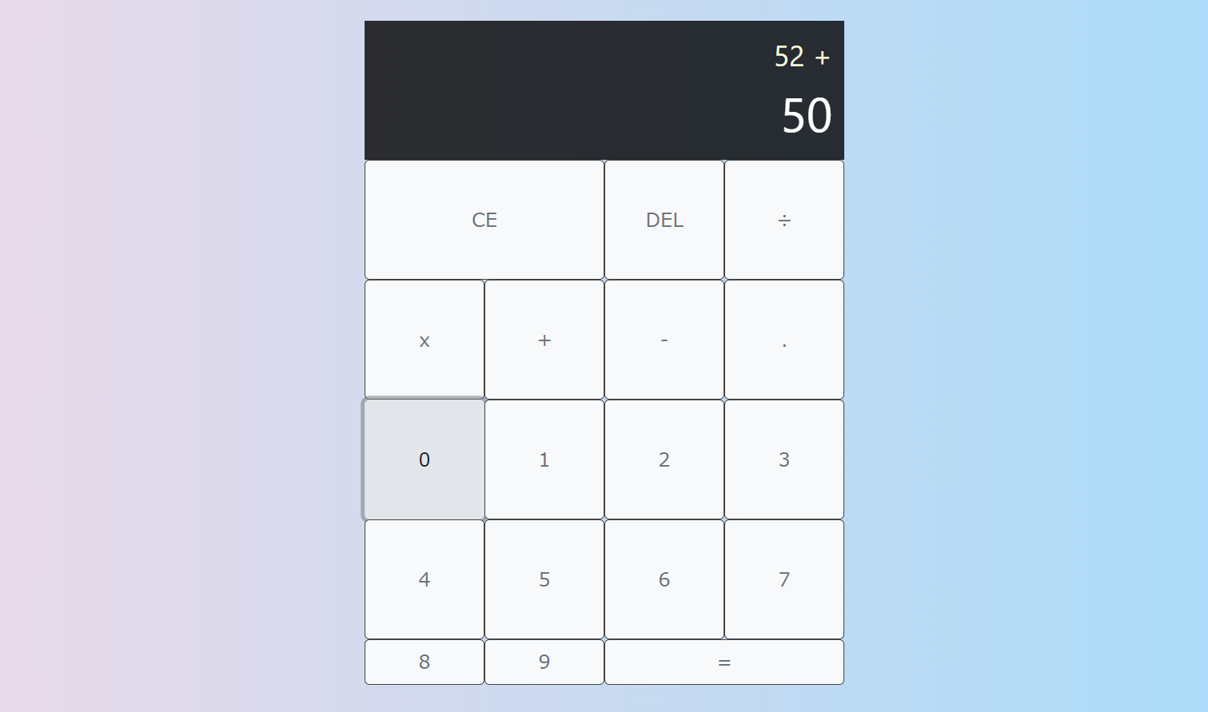

ADDITION

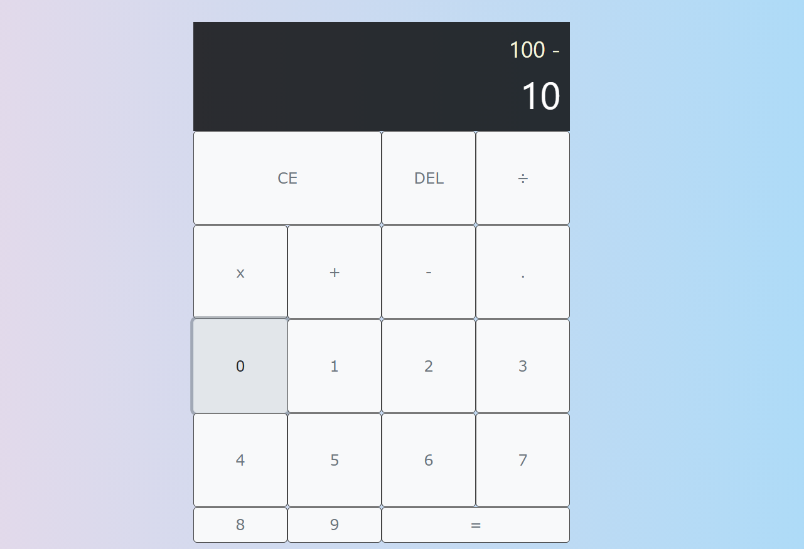

SUBTRACTION

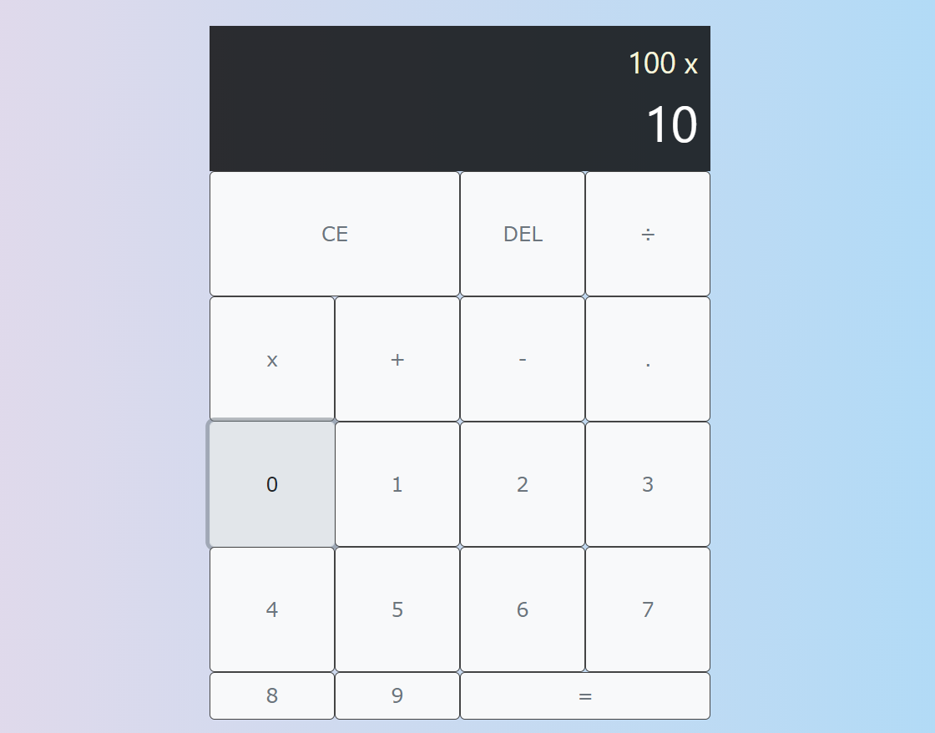

MULTIPLICATION

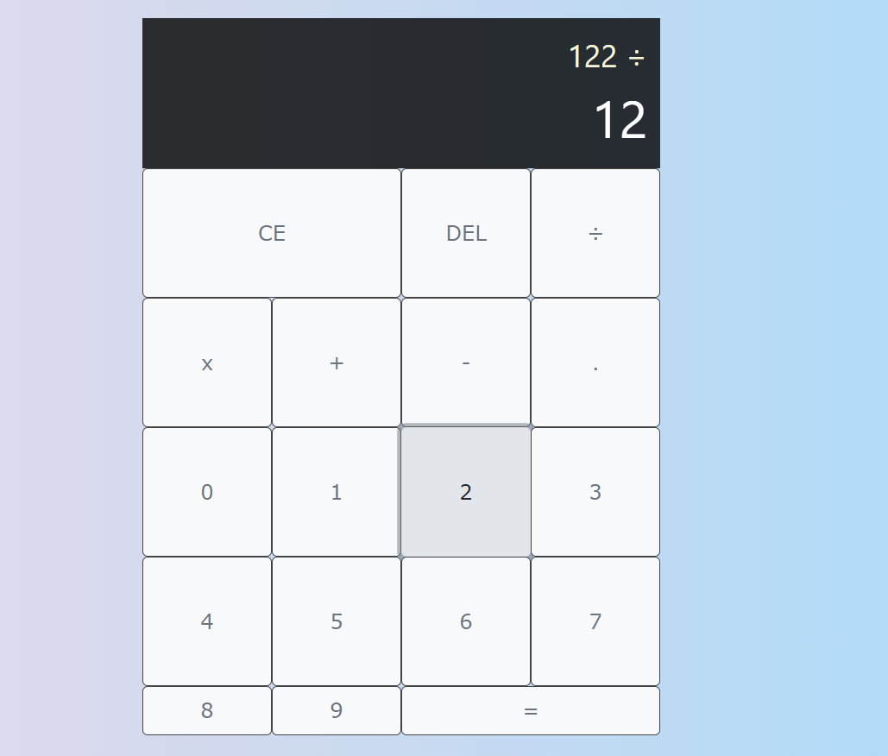

DIVISION

Project: Instrumental Website

Technologies Used: HTML, CSS and JavaScript

Description: It is a website where one can play and interact to listen instrumental sounds and can relax their mood.

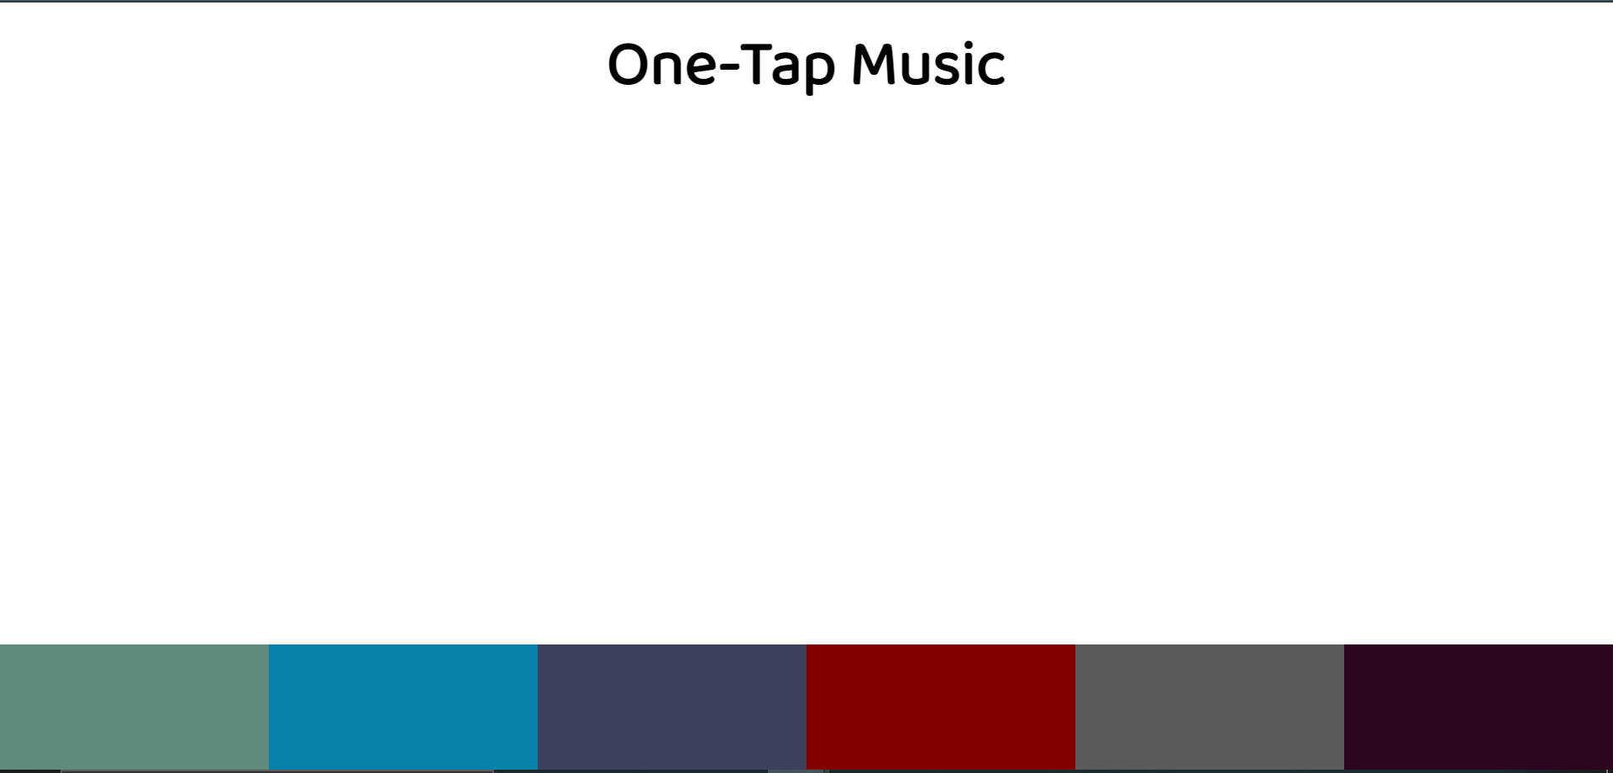

BASIC INTERFACE

Signature of External Supervisor Signature of Internal Supervisor



Note from Supervisor:
- The intern has completed the project 6 and project 7 successfully on time and the project has been verified.

- There is change in the tenure as well as in terms and conditions of the internship which the Mr. Parth Niteshkumar Patel is doing, so the new week will begin from July 27 2021.

- Mr. Parth Niteshkumar Patel has accepted the new internship offer and has agreed to extend and change their tenure of internship with us.

KINDLY TAKE NOTE OF ABOVE POINTS

Verified by: Ajay Shah.

Signature:

